Test Case: tc005_SPX_Dev5_Crear_Requisicion_Spot_Con_FAD_Tipo_Cobro_Project
Step 1 - Enter username and password and click to button Enter: Credentials Entered
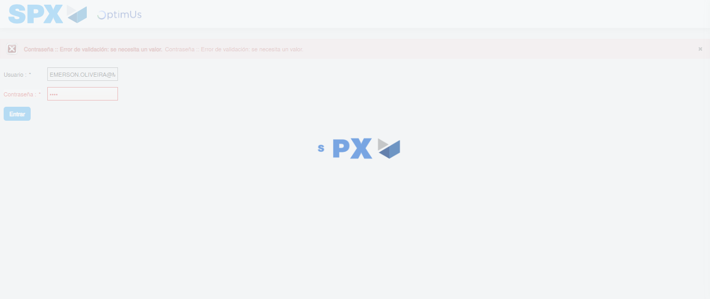Image file-name: QC_Testing-tc005_SPX_Dev5_Crear_Requisicion_Spot_Con_FAD_Tipo_Cobro_Project-1785974858707

Step 2 - Select to UEN and Access to Spot Buy Requisitions : UEN Correctly selected and Correct access
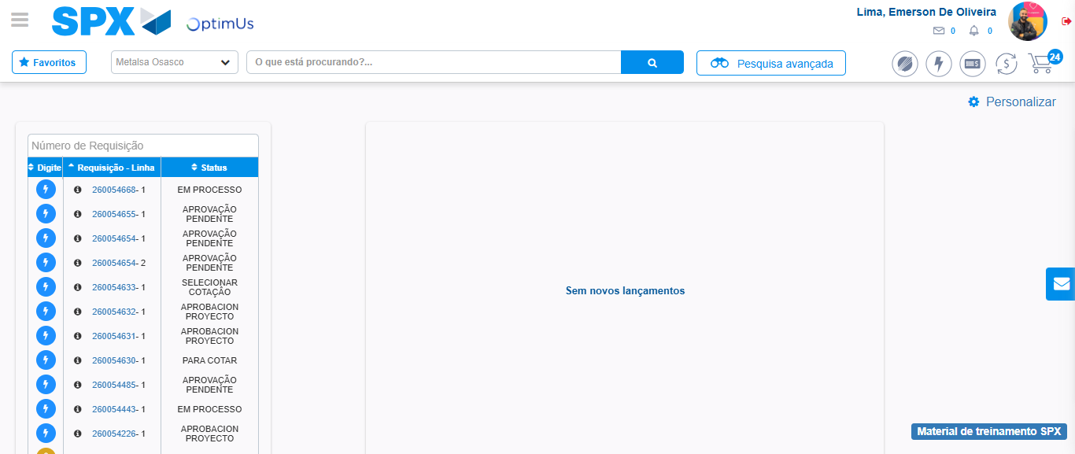Image file-name: QC_Testing-tc005_SPX_Dev5_Crear_Requisicion_Spot_Con_FAD_Tipo_Cobro_Project-1785974885760

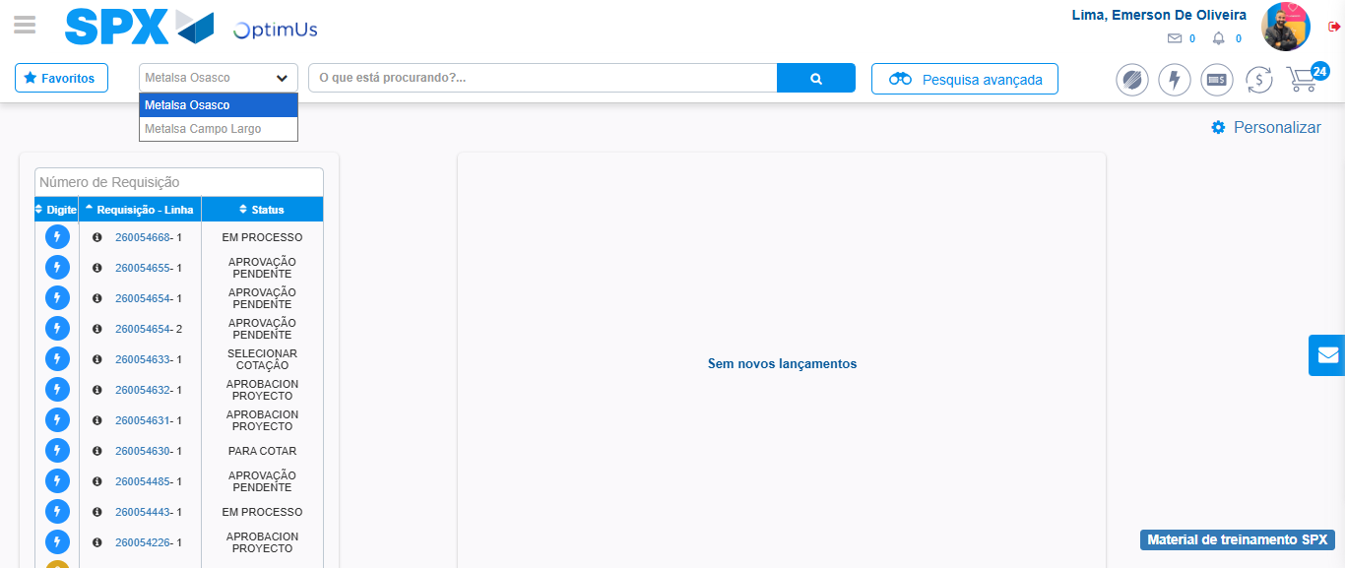Image file-name: QC_Testing-tc005_SPX_Dev5_Crear_Requisicion_Spot_Con_FAD_Tipo_Cobro_Project-1785974888296

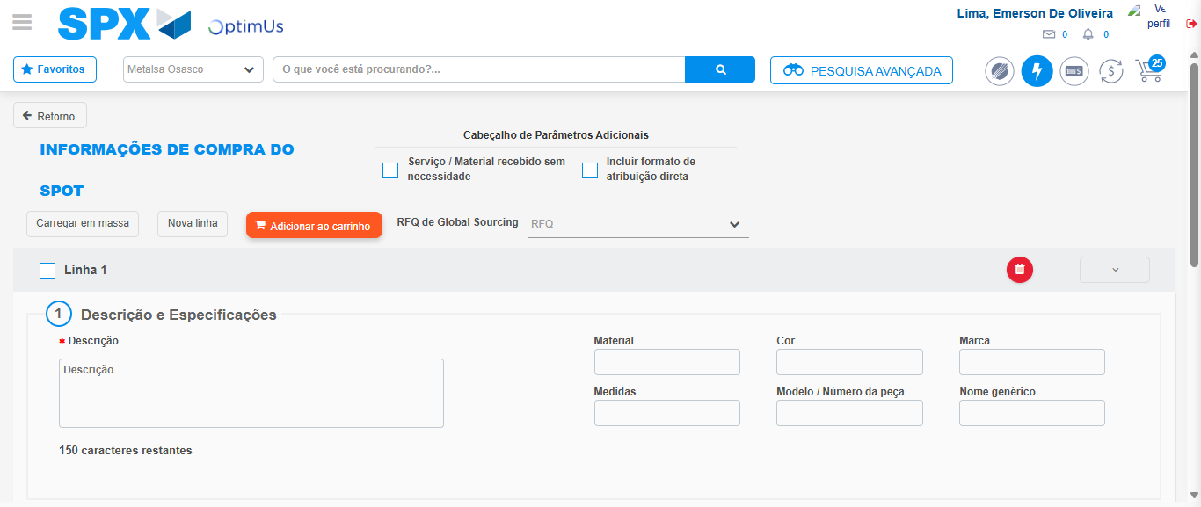Image file-name: QC_Testing-tc005_SPX_Dev5_Crear_Requisicion_Spot_Con_FAD_Tipo_Cobro_Project-1785974896137

Step 3 - Add FAD to Requisition: FAD Successfully Added
Image file-name: QC_Testing-tc005_SPX_Dev5_Crear_Requisicion_Spot_Con_FAD_Tipo_Cobro_Project-1785974896433

Image file-name: QC_Testing-tc005_SPX_Dev5_Crear_Requisicion_Spot_Con_FAD_Tipo_Cobro_Project-1785974896616

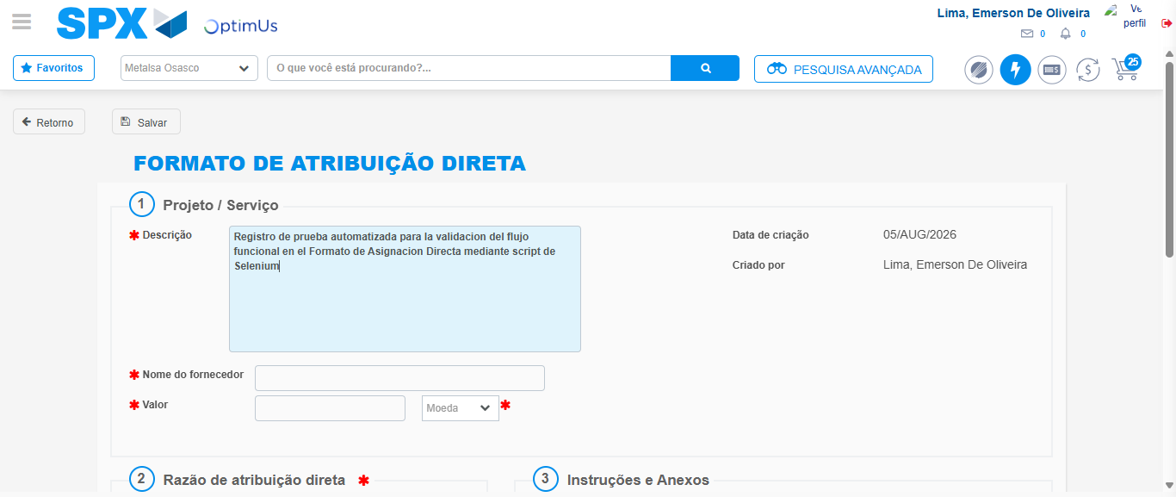Image file-name: QC_Testing-tc005_SPX_Dev5_Crear_Requisicion_Spot_Con_FAD_Tipo_Cobro_Project-1785974899371

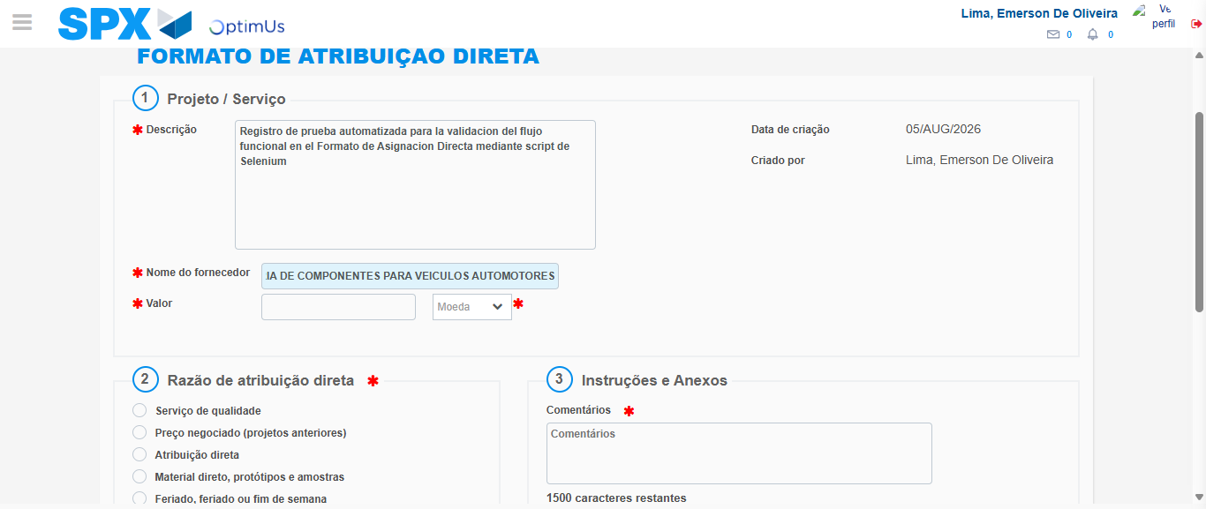Image file-name: QC_Testing-tc005_SPX_Dev5_Crear_Requisicion_Spot_Con_FAD_Tipo_Cobro_Project-1785974908808

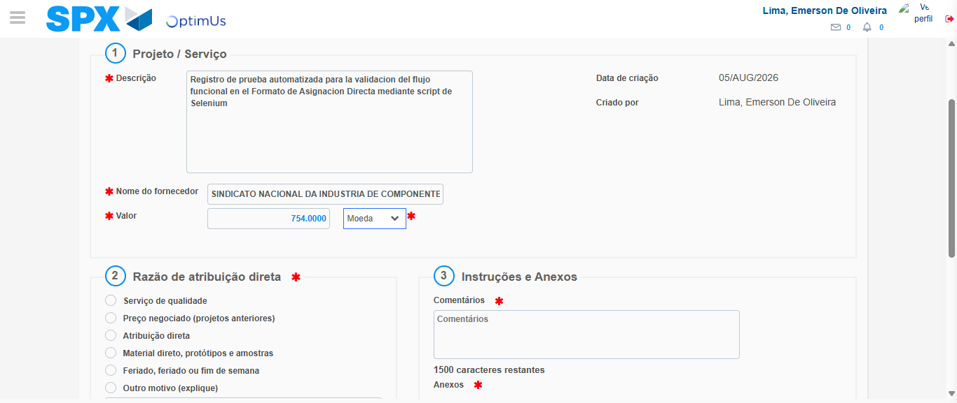Image file-name: QC_Testing-tc005_SPX_Dev5_Crear_Requisicion_Spot_Con_FAD_Tipo_Cobro_Project-1785974909291

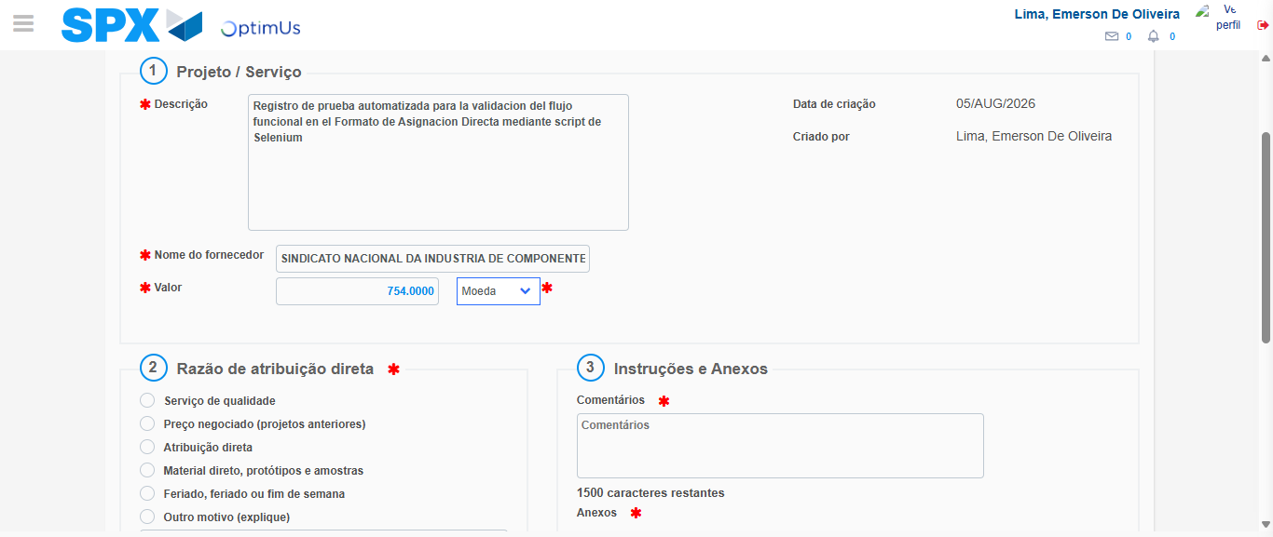Image file-name: QC_Testing-tc005_SPX_Dev5_Crear_Requisicion_Spot_Con_FAD_Tipo_Cobro_Project-1785974909526

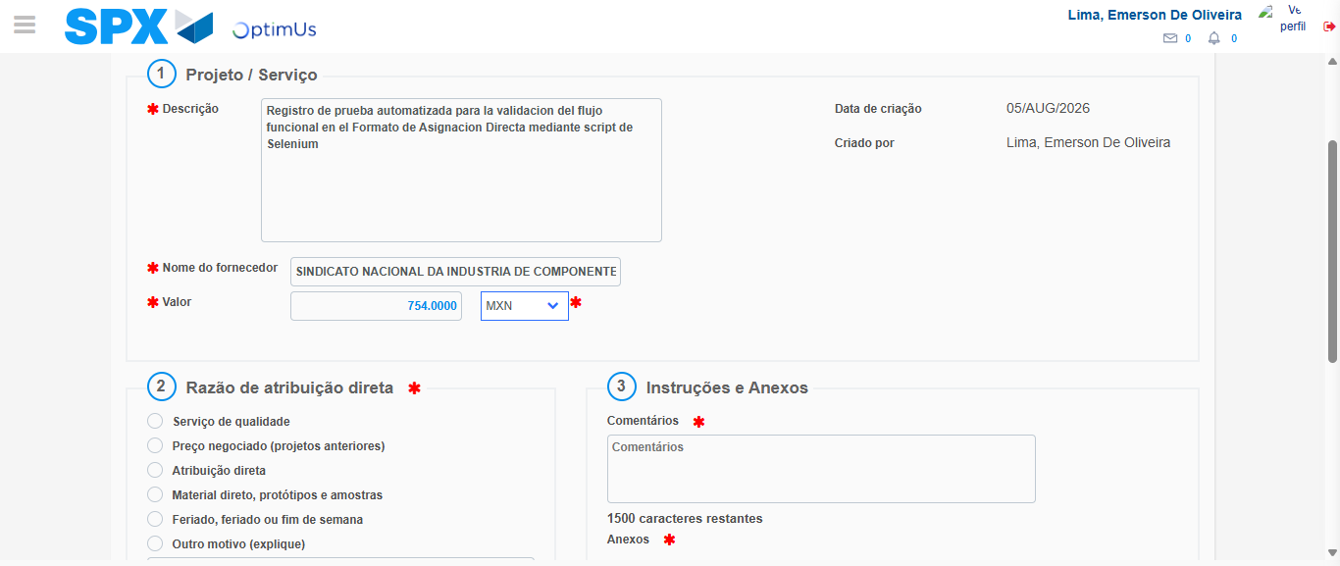Image file-name: QC_Testing-tc005_SPX_Dev5_Crear_Requisicion_Spot_Con_FAD_Tipo_Cobro_Project-1785974909931

Image file-name: QC_Testing-tc005_SPX_Dev5_Crear_Requisicion_Spot_Con_FAD_Tipo_Cobro_Project-1785974910130

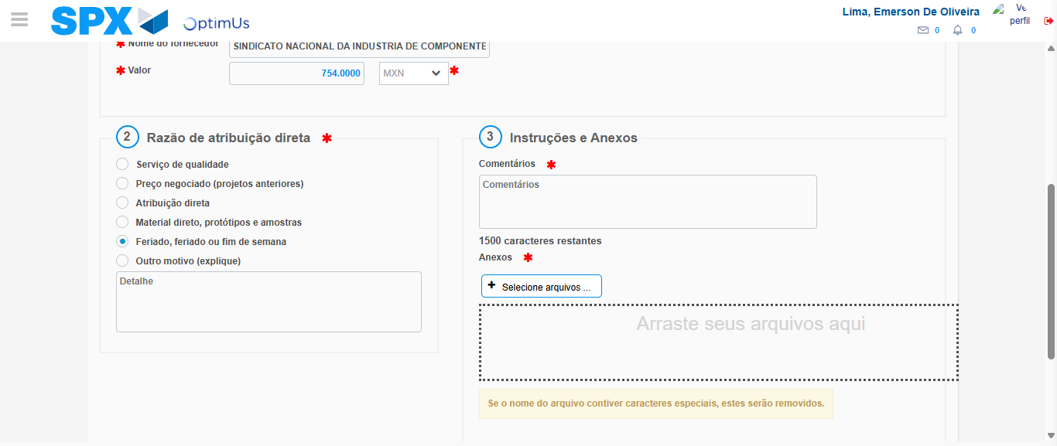Image file-name: QC_Testing-tc005_SPX_Dev5_Crear_Requisicion_Spot_Con_FAD_Tipo_Cobro_Project-1785974910969

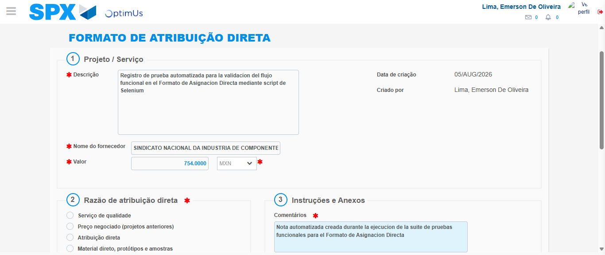Image file-name: QC_Testing-tc005_SPX_Dev5_Crear_Requisicion_Spot_Con_FAD_Tipo_Cobro_Project-1785974921999

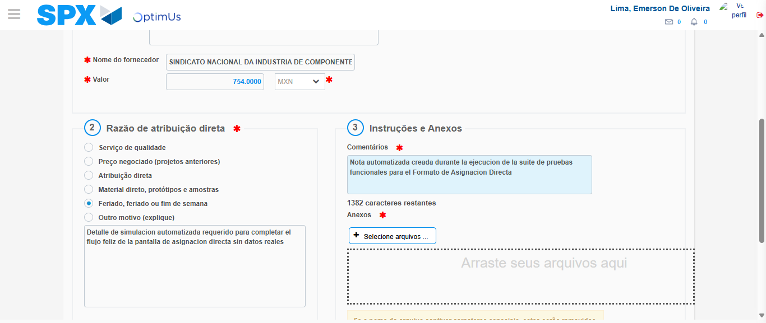Image file-name: QC_Testing-tc005_SPX_Dev5_Crear_Requisicion_Spot_Con_FAD_Tipo_Cobro_Project-1785974922853

Step 4 - Data Capture Spot Buy Requisition: Data captured correctly
Image file-name: QC_Testing-tc005_SPX_Dev5_Crear_Requisicion_Spot_Con_FAD_Tipo_Cobro_Project-1785974896433

Image file-name: QC_Testing-tc005_SPX_Dev5_Crear_Requisicion_Spot_Con_FAD_Tipo_Cobro_Project-1785974896616

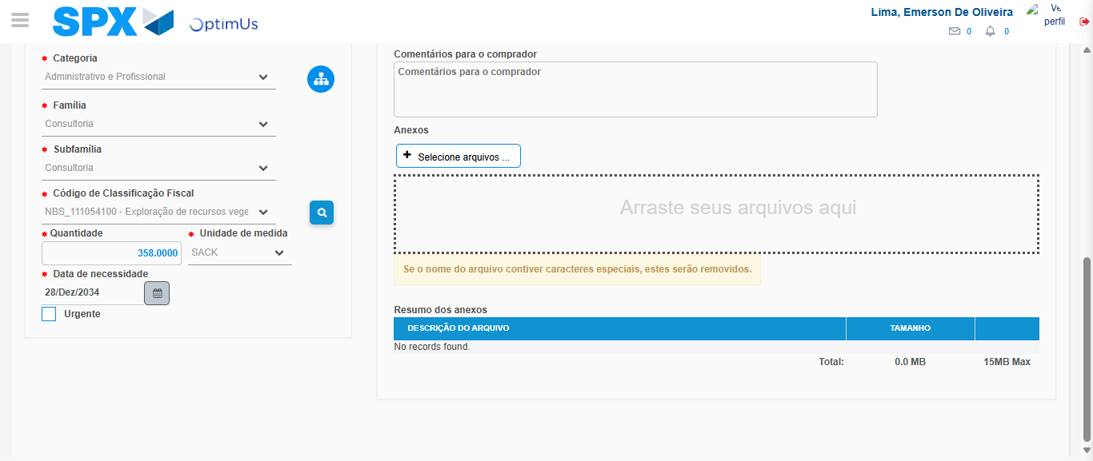Image file-name: QC_Testing-tc005_SPX_Dev5_Crear_Requisicion_Spot_Con_FAD_Tipo_Cobro_Project-1785974941091

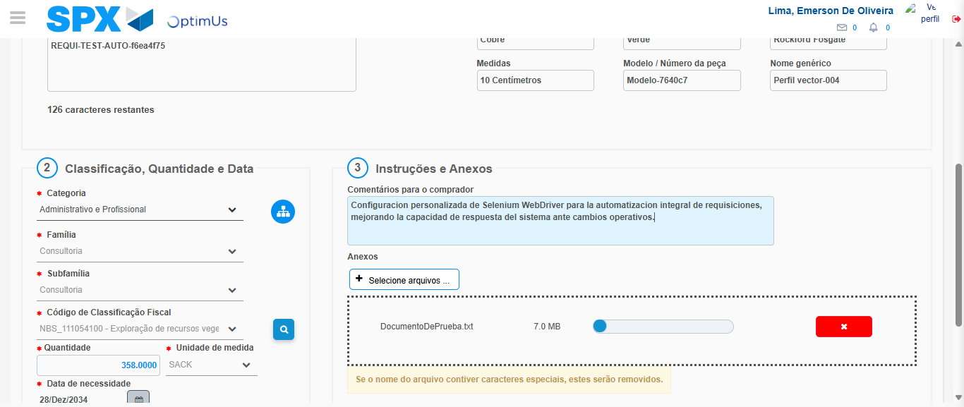Image file-name: QC_Testing-tc005_SPX_Dev5_Crear_Requisicion_Spot_Con_FAD_Tipo_Cobro_Project-1785974941847

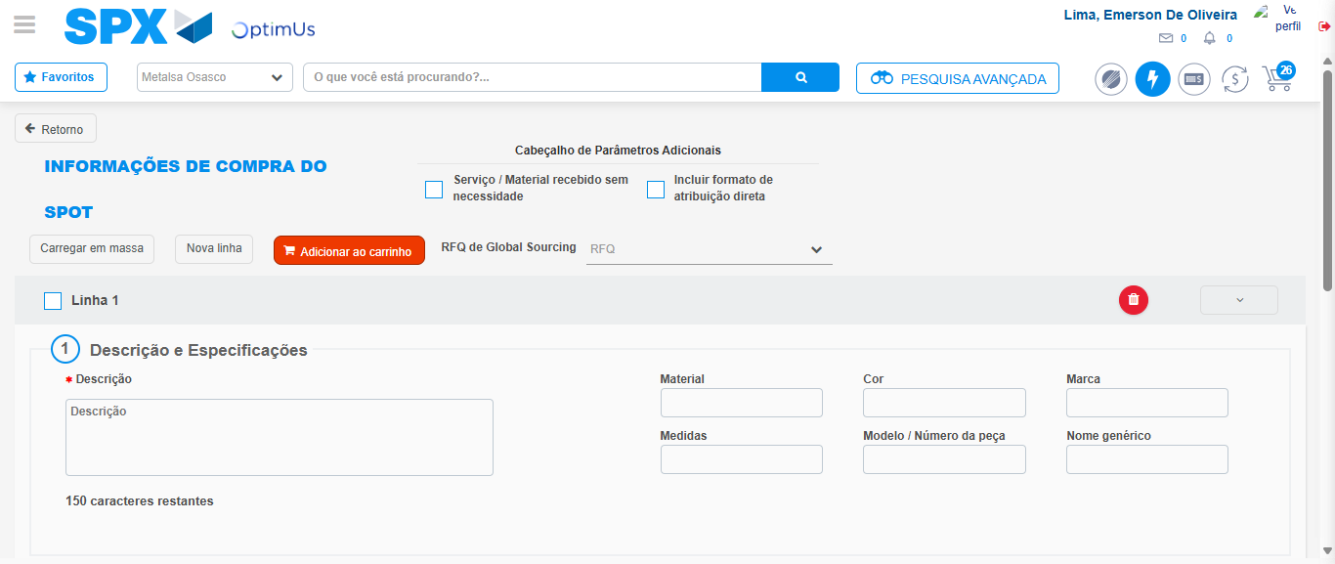Image file-name: QC_Testing-tc005_SPX_Dev5_Crear_Requisicion_Spot_Con_FAD_Tipo_Cobro_Project-1785974946373

Step 8 - Return to Main Page SPX : Return to Main Page SPX
Image file-name: QC_Testing-tc005_SPX_Dev5_Crear_Requisicion_Spot_Con_FAD_Tipo_Cobro_Project-1785974885760

Image file-name: QC_Testing-tc005_SPX_Dev5_Crear_Requisicion_Spot_Con_FAD_Tipo_Cobro_Project-1785974888296

Image file-name: QC_Testing-tc005_SPX_Dev5_Crear_Requisicion_Spot_Con_FAD_Tipo_Cobro_Project-1785974896137

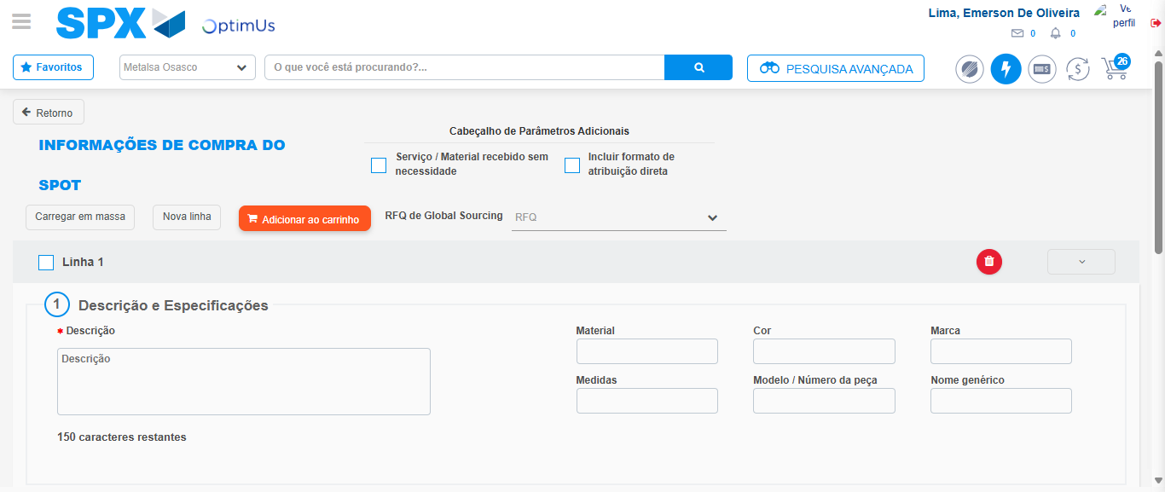Image file-name: QC_Testing-tc005_SPX_Dev5_Crear_Requisicion_Spot_Con_FAD_Tipo_Cobro_Project-1785974948730

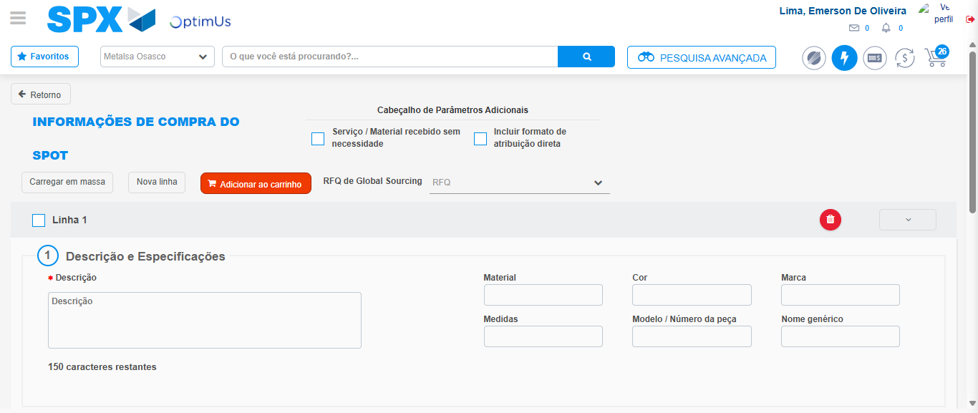Image file-name: QC_Testing-tc005_SPX_Dev5_Crear_Requisicion_Spot_Con_FAD_Tipo_Cobro_Project-1785974949005

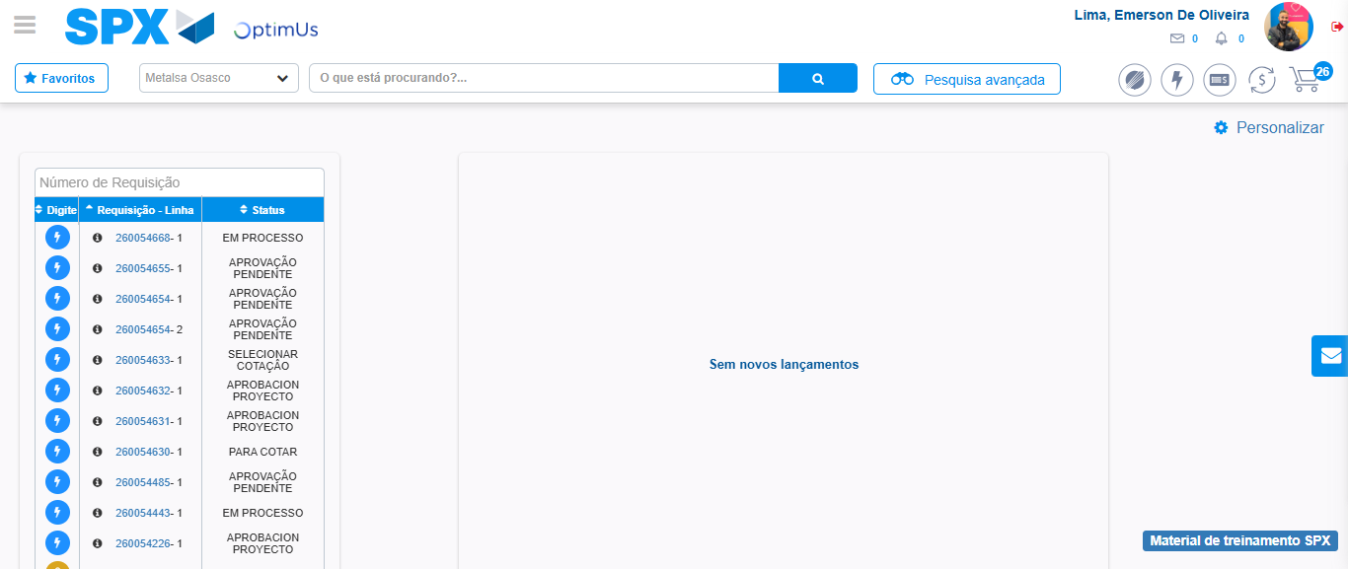Image file-name: QC_Testing-tc005_SPX_Dev5_Crear_Requisicion_Spot_Con_FAD_Tipo_Cobro_Project-1785974970101

Step 9 - Log Out : Log Out SPX
Image file-name: QC_Testing-tc005_SPX_Dev5_Crear_Requisicion_Spot_Con_FAD_Tipo_Cobro_Project-1785974970335

